Gifted Identification

If you believe your child shows some (or any) of the characteristics and behaviors of gifted students, please schedule a meeting with your child's classroom teacher and the gifted resource teacher. We are happy to talk with you about the gifted identification process.

**Important Dates**

* October 20- deadline for referring students for gifted identification
* October 30- gifted testing begins
* Gifted Education Advisory Council (GEAC) Meetings:

|  |  |
| --- | --- |
| October 3, 2017  November 7, 2017  December 5, 2017  February 6, 2018 | March 6, 2018  April 3, 2018  May 1, 2018  June 5, 2018 |

Meetings @ 6:00 Academy of International Studies Media Center

**Why Gifted Education?**

Gifted children are different from their same-age peers in many ways. Many gifted students learn to read early, learn basic skills sooner and make connections easier than their same-age peers. Often, it's not just getting the right answer that shows a child's giftedness, but *how* he/she got that answer. Therefore, the educational needs of gifted students are different, and specialized instruction is indicated.

**Resources for Parents**

National Association for Gifted Children- <http://www.nagc.org/resources-publications/resources-parents>

Supporting the Emotional Needs of the Gifted

<http://sengifted.org/about-seng>

Hoagies’ Gifted Education Page

<http://www.hoagiesgifted.org/>



*The important thing is not to stop questioning. Curiosity has its own reason for existing. One cannot help but be in awe when he contemplates the mysteries of eternity, of life, of the marvelous structure of reality. It is enough if one tries merely to comprehend a little of this mystery every day. Never lose a holy curiosity*.

– Albert Einstein



Lake Taylor Middle School

**Dr. Melanie Patterson, Principal**  
1380 Kempsville Road  
Norfolk, VA. 23502

**Phone**: (757) 892-3230  
**Fax**: (757) 892-3240

[mpatterson@nps.k12.va.us](mailto:mpatterson@nps.k12.va.us)

**Office Hours**  
Monday-Friday  
7:30 a.m. - 3:30 p.m.

**Student Hours**  
8:15 a.m. - 2:45 p.m.

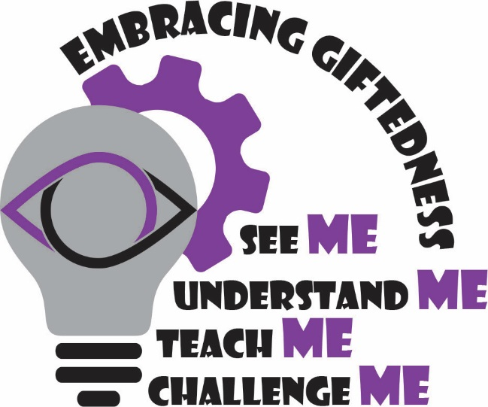

*Spencer Jamison*

*Gifted Resource Teacher*

sjamison@nps.k12.va.us

**The Gifted Resource Teacher will:**

* Work with your child to build critical thinking and problem solving skills
* Assist students when applying to High School Specialty programs
* Collaborate with classroom teachers to provide support for accelerated and differentiated instruction
* Facilitate the gifted identification process for all students referred for gifted identification
* Provide training and professional development for all teachers in the area of gifted education
* Provide parents with information related to gifted education a variety of gifted topics

*Genius without education is like silver in the mine.* – Benjamin Franklin

Activities & Competitions

|  |
| --- |
| ***Middle School:***   * WordMasters * **Battle of the Books** * Courtroom Law * Forensics/Debate |
|  |

**Gifted/Honors Classroom Environment**

Gifted students will receive services from their Gifted Resource at least once per week, according to their area of identification.

The Resource classes are specially designed to offer gifted students the opportunity to collaborate with their intellectual peers, to explore areas of interest, and to expand and deepen their knowledge and application of the school curriculum. Additionally, gifted students will build critical thinking and problem-solving, as well as leadership skills.

Middle school gifted students will be served in the honors classrooms via collaboration and co-teaching between the content teacher and the gifted resource teacher.

The Gifted Resource Teacher incorporates a variety of teaching models and strategies to meet the unique needs of each gifted student. A strengths-based approach to teaching and learning is utilized to maximize areas of strength while simultaneously addressing areas of weakness.

The gifted/honors classroom features:

Seminar and Cohort learning

Differentiated Instruction

Technology/Media Centered learning

Collaborative Learning Experiences

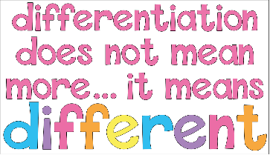

**Models of Gifted/Honors Instruction**

* Habits of Mind
* Authentic Research
* Junior Great Books
* The Jacob’s Ladder Reading Comprehension Program
* Culturally Responsive Learning Experiences
* Differentiating Instructions With Menus
* William and Mary Units

### **Student Outcomes**

* Increased metacognitive abilities (thinking about one’s thinking)
* Increased achievement on standardized assessments (SOL, SAT)
* Participation in rigorous courses of study
* Exploration and development in areas of interest and passion
* Development of critical thinking and problem-solving skills
* Study of computer sciences through the creation, presentation, and demonstration of products.